26/06/2017



Project Boulder Dash

By Tom Brunetti, Geoffroy De-Felcourt, Thibault Michel et Antoine Masalsky

CESI.Exia

Sommary :

1. Problematic………………………..…………………………………Page 2
2. Presentation of members………………………………………Page 2
3. Previsional and real planner..…………………………………Page 2
4. Daily logbook
5. UML
6. Packages diagram
7. Composants diagram
8. Sequences diagram
9. Classes diagram
10. JavaDoc
11. JXR
12. SureFire report
13. Git report
14. Data Base
15. Global Bilan
16. Personnal Bilan
17. Antoine Masalsky
18. Thibault Michel
19. Tom Brunetti
20. Geoffroy De-Felcourt

# **Problematic:**

Our objective is to recreate an old abandonware called « Boulder Dash ».

The main directive is to use UML and Java languages.

We have too some contraint :

* The levels must be socked in a data base.
* We can’t use an other graphic framework than Spring
* We must create a Git project, use the architecture Maven and his plugin JUnit.

# **Presentation of members:**

# Previsional and real planning

* Previsionnel :

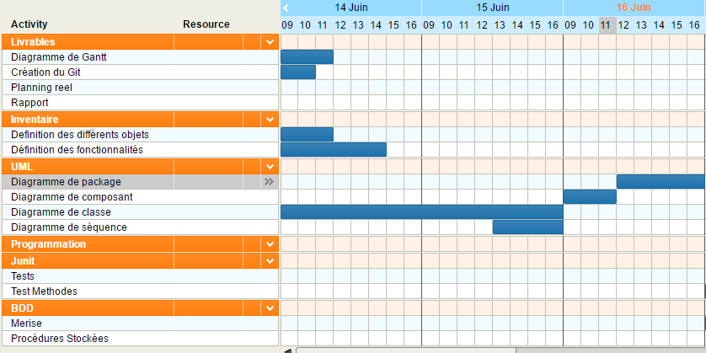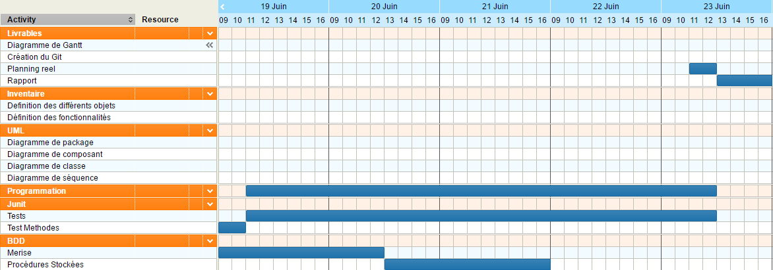

* Real :

# **Daily logbook**

Wednesday June’s 14th :

* Creation and configuration of our Git network
* projected planning
* Creation of the main structure of our program
* Definition of the mains methods
* Creation of composant diagram
* Creation of the class diagram

Thursday June’s 15th :

* Final revision for CCTL
* Fix incoherance of composant diagram
* Fix incoherance of class diagram
* Fix incoherance of the Git Network
* Creation of the UML diagram
* Creation sequencies diagram
* Definition of secondaries methods

Friday June’s 16th :

* Finishing of composant diagram
* Finishing of class diagram
* Finishing of sesquencies diagram
* Fix incoherance of UML diagram

Monday June’s 19th

# **UML**

## Packages Diagram

## Composant Diagram

## Sequencies Diagram

## Classes Diagram

# **JavaDoc**

# **JXR**

# **SureFire report**

# **Git report**

# **DataBase**

# **Global Bilan**

# **Personnal Bilan**

## Antoine Masalsky

## Thibault Michel

## Tom Brunetti

## Geoffroy De-Felcourt